**Hospital Admission Prediction using Artificial Intelligence**

**ABSTRACT**

People will have a difficult time getting admitted to hospitals. They should plan to wait in line for many hours if the hospital is busy. However, it is quite poor in the Emergency Room. The emergency room is used for the most severe situations. Therefore, we need to use more cutting-edge methods to improve the flow of patients and forestall overcrowding. Consequently, we may anticipate ED admissions in a pleasant manner using data mining approaches. In this analysis, we looked at the Naive Bayes, Random Forests, and Support Vector Machine algorithms for forecasting models. Age, systolic blood pressure, diastolic blood pressure, diabetes, prior records in the preceding month or year, and admission are all important elements to consider when making a prognosis about a hospitalization. We also provide specifics on the algorithms we used. The accuracy of our predictions is enhanced by using the Random Forests technique to sort the data into several classes. To better forecast the result, Naive Bayes is utilized to calculate the probability associated with each characteristic. It is possible to anticipate a result by using a Support Vector Machine to categorize the input into a certain category.

**OBJECTIVE & SCOPE OF THE PROJECT:**

**OBJECTIVE:**

Our research was driven by two primary goals. Our primary goal is to construct a model that can reliably predict whether or not a patient seen in the ER will be taken into the hospital. In the future, we want to investigate how alternative machine learning techniques do in this field. Predicting a patient's condition requires a firm grasp of a number of different statistical equations. The goal is to identify the most effective model for predicting ED admission. Here, we look at the similarities and differences of three commonly used algorithms: Naive Bayes, Support vector machine (SVM), and Random Forest classifier. Support Vector Machines Produce the Most Accurate Results Compared to Other Strategies.

**SCOPE:**

As a result of the scarcity of necessary employees, waiting times will grow dramatically, and by the time anybody notices, it will be too late to take any action. To alleviate patient congestion and enhance patient flow, we must develop novel strategies to address this worldwide problem. Predicting the health of hospitalized emergency patients by data mining employing a variety of ML algorithms has shown to be an effective strategy in recent years.

**PROPOSED SYSTEM:**

The primary goal of this research is to determine how to best use existing machine learning algorithms and build new models to forecast the health of incoming emergency room patients. We will also evaluate our model's results in comparison to those of many other methods currently in use. There are a number of steps that patients, both those who have scheduled appointments and those who have arrived at the hospital as part of an emergency, must do before they are released from the hospital. The emphasis in these stages will be on the numerous choices they faced in the preceding stages. Patient information such as age, gender, blood pressure (systolic and diastolic), diabetes, and medical history will be gathered at these times, and admission decisions will be made accordingly. The average annual growth rate for inpatient stays was 5.7%, with a cumulative growth rate of 64.1%; the average annual growth rate for ER visits was 8.0%, with a cumulative growth rate of 99.4%. The goal is to identify the most effective model for predicting ED admission. Here, we look at the similarities and differences of three popular machine learning algorithms: Naive Bayes, Support vector machine (SVM), and Random Forest classifier. Support Vector Machines Produce the Most Accurate Results Compared to Other Methods.

**PROJECT DESIGN:**

**DATA FLOW DIAGRAM:**

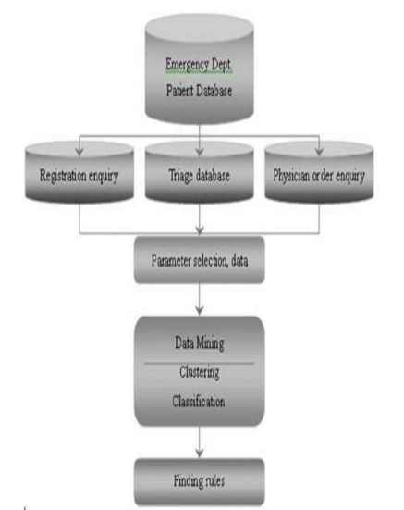

**USE CASE DIAGRAM:**

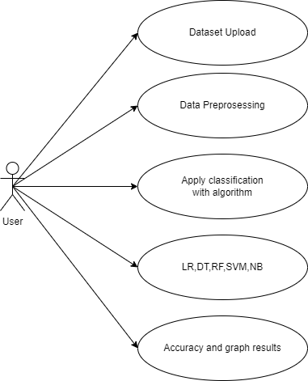

**CLASS DIAGRAM:**

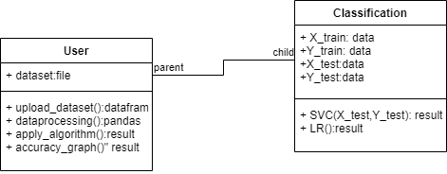

**SEQUENCE DIAGRAM:**

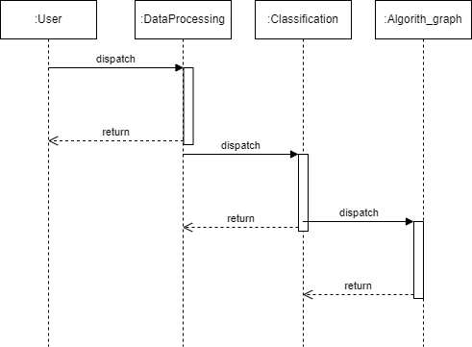

**PROJECT IMPLEMENTATION:**

**Project Implementation Technology:**

The project developing using python3.7 version in that we used IDEL and TK-Intern for UI for window based UI designing. Some of library I use in my project those are pandas, NumPy, matplotlib, sklearn, Keras, TensorFlow.

**Software requirements**

**• Programming Language: Python, Colab**

**• Packages: NumPy, Matplotlib, SKLearn, Pandas**

**• Tool: Python 3.7**

**Data set description:**

For hospital admission prediction we take patients data. This data consists fifty columns and 101766 records.

**MODULES:**

* Upload patient database & dataset
* Datamining clustering
* Classification of data
* Find rules & graph implementation

**HARDWARE REQUIREMENTS:**

* System : Intel core I5.
* Hard Disk : 512 GB.
* Monitor : 15 LED
* Input Devices : Keyboard, Mouse
* Ram : 8 GB

**SOFTWARE REQUIREMENTS:**

* Operating system : Windows 10
* Coding Language : Python
* Tool : IDLE, colab

**REFERENCES**:

[1] Li JYZ, Yong TY, Bennett D Et al. Outcome of the interposition of an acute assessment unit in the general medical service of a tertiary teaching hospital. Med. J. Aust. 2010; 192:384–7.

[2] Prakash, K.B. & Dorai Rangaswamy, M.A. 2016, "Content extraction studies using neural network and attribute generation", Indian Journal of Science and Technology, vol.9,no.22,pp.1-10.

[3] O‘Brien D, Williams A, Blondell Ket al. Impact of streaming ‗fast track‘ emergency department patients. Aust.Health Rev. 2006; 30: 525–32.

[4] King DL, Ben-Tovim DI, Bassham J.Redesigning emergency department patient flows: application of Lean Thinking to health care. Emerg. Med.Australas. 2006; 18: 391–7.

[5] Gardner RL, Sarkar U, Maselli JH et al. Factors associated with longer ED lengths of stay. Am. J. Emerg.Med. 2007; 25: 643–50.

[6] Prakash, K.B. 2018, "Information extraction in current Indian web documents", International Journal of Engineering and Technology(UAE), vol. 7, no. 2, pp. 68-71.

[7] Emergency Department Overcrowding in Massachusetts. Making Room in our Hospitals. Issue Brief.The Massachusetts Health Policy Forum, No 12; 2001.

[8] National Hospital Ambulatory Medical Care Survey. 2002 Emergency Department Summary. Advance Data Number 340.35pp.(PHS) 2004-1250.